## **Project Process Book – Assignment 3B**

**Project Title:** Compared Australia and USA Unemployment Range (2020–2024) Across OECD  
 **Mercury Link:** <https://mercury.swin.edu.au/cos30045/s104000839/Assignment3/OECD%20Dataset.html> **Team Name:** [1F]  
 **Team Members:** [Aung Thiha, Jampot Thongdee]  
 **Teaching Period:** TP2

### **Introduction**

This project aims to compare the annual unemployment rates of **Australia and the United States** between **2020 and 2024**. The primary dataset was sourced from the **OECD database**, and the project focuses on visualising these values in an accessible and engaging format using D3.js. Our objective is to present trends in unemployment, highlight the economic effects of global events such as the COVID-19 pandemic, and illustrate potential patterns of recovery or fluctuation over the selected years.

### **Visualisation Purpose**

The core purpose of this visualisation is to allow viewers to observe and compare the unemployment rates of **Australia and the US** side-by-side. The chosen format—**a grouped bar chart**—displays unemployment data year by year, making it easy to identify how each country’s rate evolved. We aim to present this comparison in a clear, readable, and interactive form. While the project scope remains simple, it provides enough context and functionality to explore basic economic insights between the two countries.

### **Project Schedule**

|  |  |
| --- | --- |
| **Week** | **Planned Tasks** |
| Week 8 | Built grouped bar chart in D3.js and added interactive tooltips |
| Week 9 | Drafted Project Process Book; refined visual styling and spacing |
| Week 10 | Completed internal review and final debugging across multiple devices |
| Week 11 | Finalised documentation, added citations, tested deployment on Mercury |
| Week 12 | Reserved for final submission confirmation and final review (if needed) |

### **Data**

The **OECD unemployment dataset** was selected for its reliability and comprehensive coverage of global unemployment statistics. For this project, we filtered the dataset to include only **Australia and the United States** and limited it to data from **2020 to 2024**. The following attributes were used:

* **Country**: Australia or United States
* **Year**: 2020, 2021, 2022, 2023, 2024
* **Unemployment Rate (%):** Numeric percentage representing annual unemployment

We manually cleaned and transformed the dataset into a JSON-friendly format for D3.js. The final version included only the relevant values needed for charting and interaction.

### **Requirement**

The assignment required building a **data visualisation website** using **D3.js** as the primary technology. The visualisation had to include:

* **Interactive elements** (e.g., tooltip, hover effects)
* **Responsive design** that adjusts to different screen sizes
* A clear comparison of at least two variables or categories
* Supporting written documentation detailing methodology and challenges

Our solution satisfied these requirements with a **D3.js bar chart**, dynamic tooltips, a clean responsive layout, and a fully functional deployment on the **Mercury server**.

### **Visualisation Design**

We used a **grouped bar chart** to display unemployment data from 2020 to 2024. Each year displays two bars side-by-side—one for Australia and one for the US. We selected distinct but colour-blind–friendly hues for each country to ensure visual accessibility. Other design choices included:

* **X-Axis:** Years (2020–2024)
* **Y-Axis:** Unemployment Rate (%)
* **Tooltip:** On hover, displays exact rate and country
* **Legend:** Identifies colours corresponding to each country
* **Font & Spacing:** Adjusted for mobile and desktop responsiveness

The design remained minimalist, with a focus on **clarity** and **usability** rather than excessive styling. This approach allowed us to focus on core learning objectives like D3 implementation and basic data storytelling.

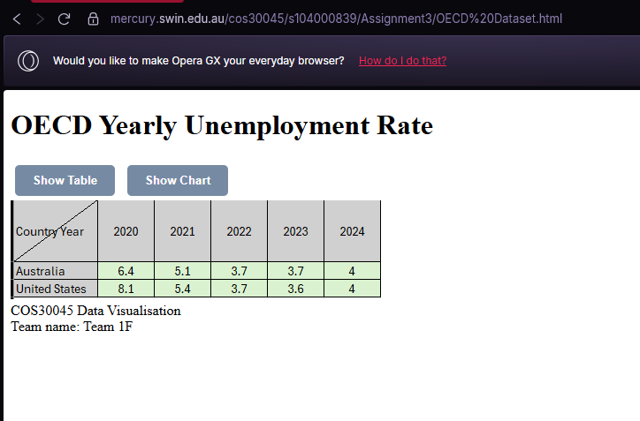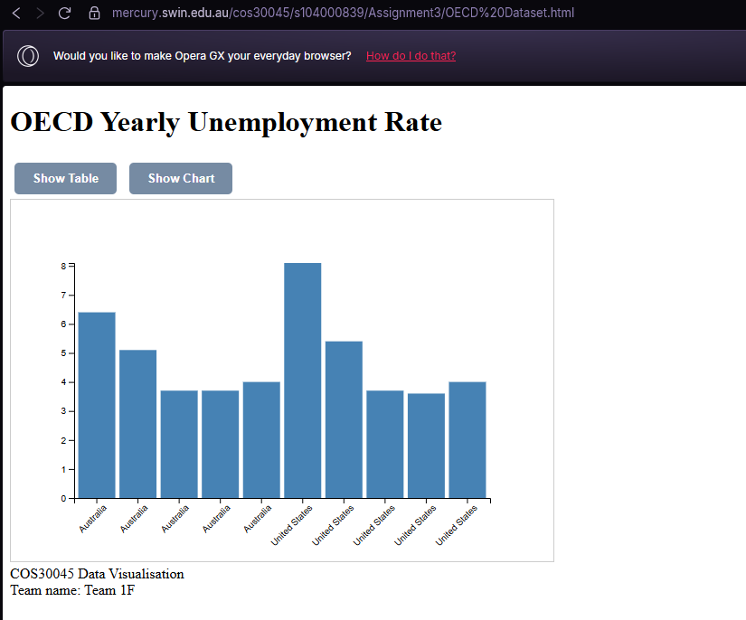

### **Validation**

To ensure the project met all expected functionality and learning outcomes, the following validation steps were taken:

* **Data Accuracy:** Double-checked the OECD dataset values against original CSV files
* **Cross-Device Testing:** Verified that layout and interactivity worked on Chrome, Firefox, Safari, and mobile browsers
* **Peer Review:** Received feedback from team members and resolved bugs related to tooltip placement and label overlapping
* **Requirement Checklist:** Compared the website against rubric criteria (interactivity, responsiveness, correct data use, documentation)

We did not rely on third-party libraries beyond D3, and all code was written and tested by the team. Any inspiration or code snippets from tutorials were acknowledged in the code comments.

### **Conclusion**

This project successfully met its objectives through a simple yet functional D3.js-based interactive visualisation. By narrowing the focus to only two countries and five years, we avoided overcomplication and created a product that is readable, functional, and informative.

Despite limited complexity, we demonstrated the ability to process real-world data, create a clear visual story, and manage a web-based technical project from start to finish. Challenges such as responsive layout issues and tooltip formatting were overcome through testing and collaboration.

We believe our final product aligns with the unit’s expectations and effectively demonstrates our learning from the capstone project.

### **References**

* OECD (2024). *Unemployment Rate by Country (2020–2024)*. Retrieved from: <https://data.oecd.org>
* Bostock, M. (D3.js documentation). <https://d3js.org/>
* W3Schools. (2024). *JavaScript and CSS Responsive Design Tutorials*. [https://w3schools.com](https://w3schools.com/)
* Mozilla Developer Network (MDN). [https://developer.mozilla.org](https://developer.mozilla.org/)